
Company
Logotype

Cone Beam Computed Tomography- Report



Porur Dental X-rays & CBCT

Patient Name : Miss. Divya | Date of Report : 18.06.2024
Age/ Gender : 24 years/ Female | Region of Interest : CBCT Sectional Mandible
Referring doctor: Dr. S. Thirupura Sundari | Indication : Pain in left lower region
Clinical Notes: Nil
PATIENT INFORMATION

CBCT- Sectional Mandible provided
CBCT – IMAGE DETAILS

RADIOGRAPHIC INTERPRETATION

- In relation to the inter- radicular region of 34, 35 presence of a hypodense region involving the apical third of root and extending beyond the periapical region of 34, upto the apical third of 35, measuring 8.38 x 9.01 x 11.8 mm in dimension, with diffuse borders.
- The hypodense region appears to be in contact with the inferior alveolar nerve canal near the mental foramen, and appears to cause thinning of the labial and lingual cortical bone.

RADIOGRAPHIC IMPRESSION

- Periodontal abscess: in relation to 34, 35

[Note: Suggested to take an IOPA of 34, 35 and suggested to perform Pulp testing of 34, 35]

Kindly correlate with clinical findings


IMAGES FOR REFERENCE

RECONSTRUCTED PANORAMIC VIEW
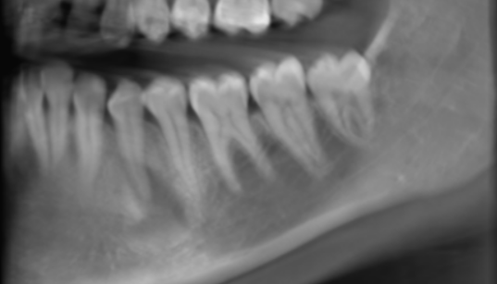

3-DIMENSIONAL VIEW

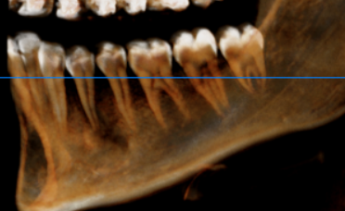

CROSS SECTIONAL VIEW

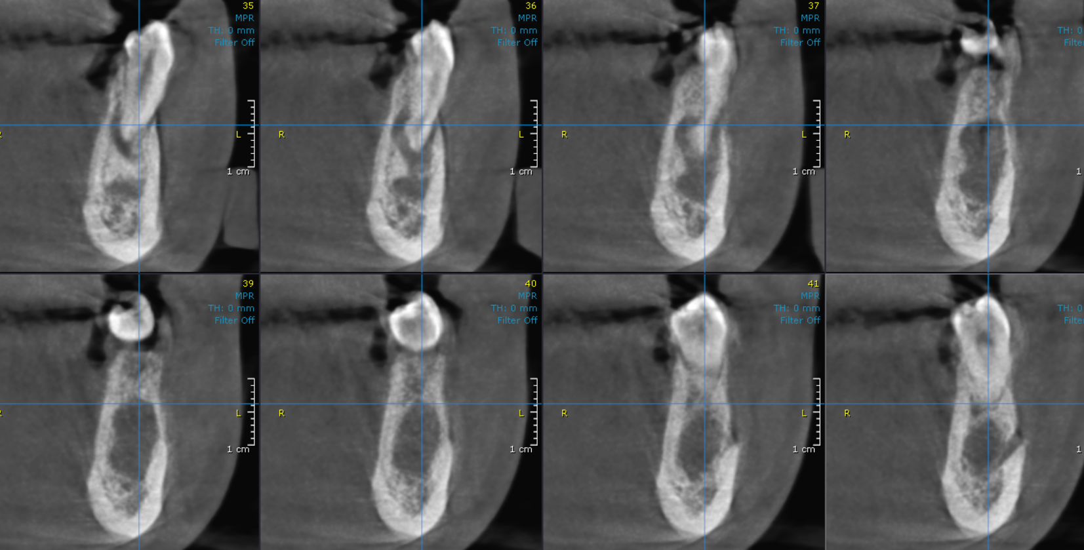
34, 35 region

AXIAL VIEW
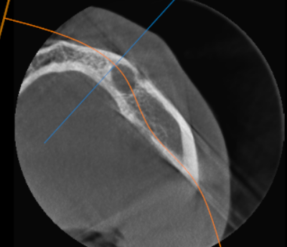

CORONAL VIEW
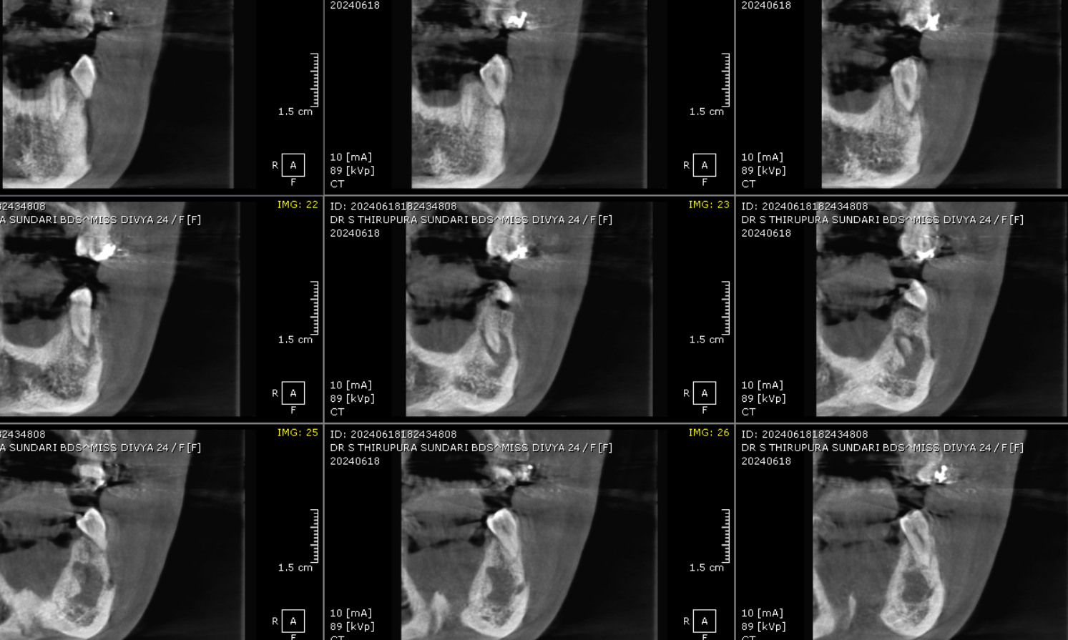

SAGITTAL VIEW
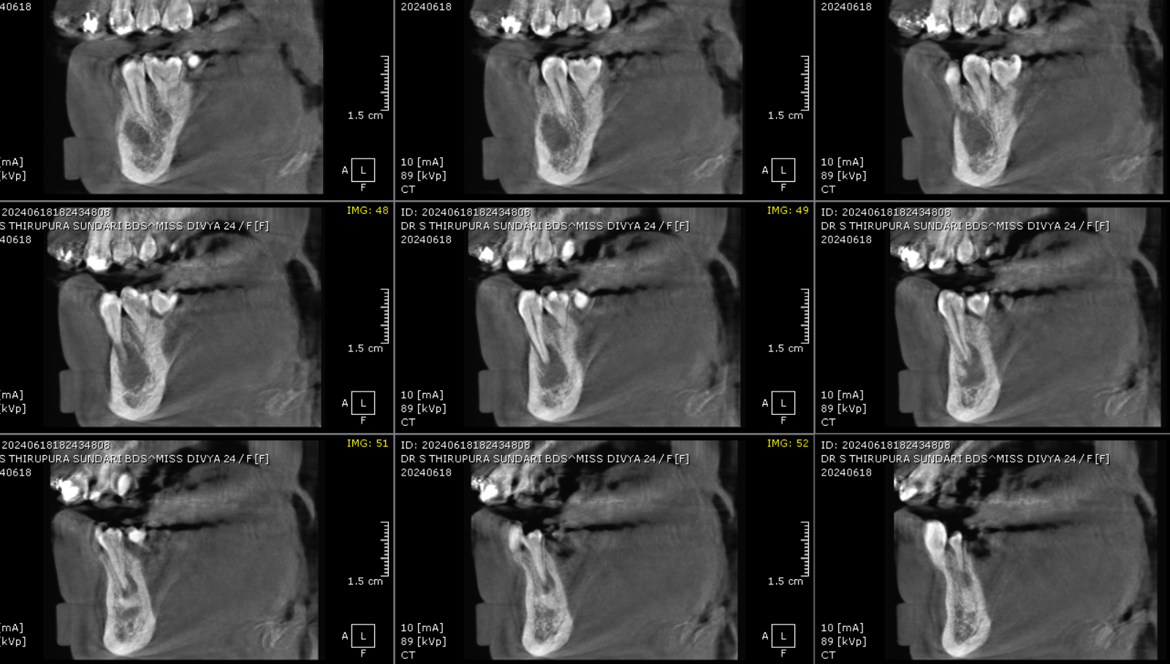
**** End of report ****

